*Florida International University*

*School of Computing and Information Sciences*

CIS 4911 - Senior Capstone Project

Software Engineering Focus

User Manual

LegalWise 2.0

**Team Members:**

Fernando Gomez

Yang Zhang

**Product Owner(s)**:

Jaime Borras

**Mentor(s)**:

Jaime Borras

**Instructor**:

Masoud Sadjadi

# For Registered Users

## Login

1. Go to the Login page of LegalWise 2.0: <http://legalwise2ui.mybluemix.net/>
2. Enter your username and password.
3. Click login button

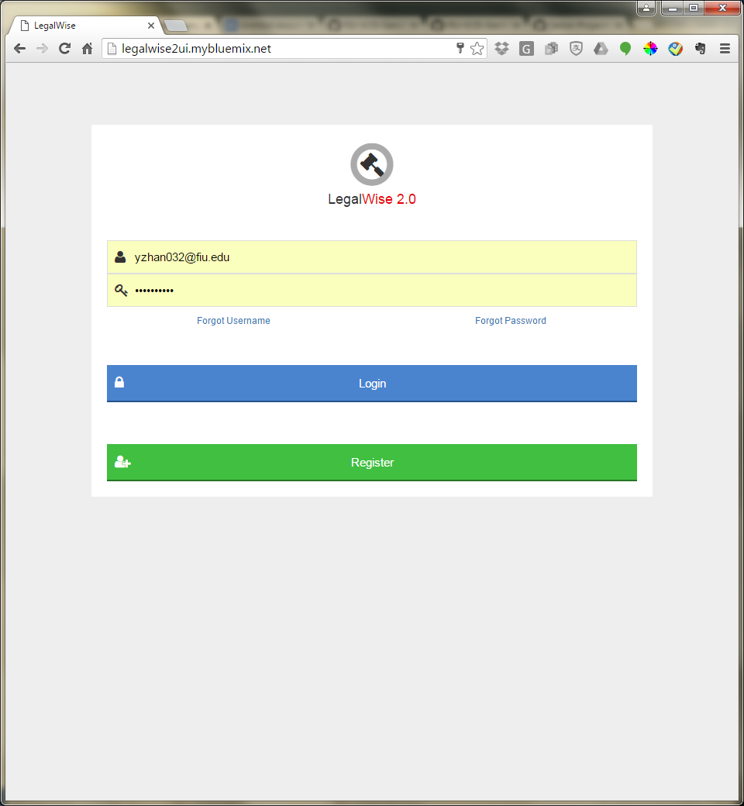

1. After logged in, you may see your user type at the up right corner.



## Search & Download

1. After login, you will see this search page. Enter your question or key words in the search box.
2. e.g. “What is the statute of limitation?”

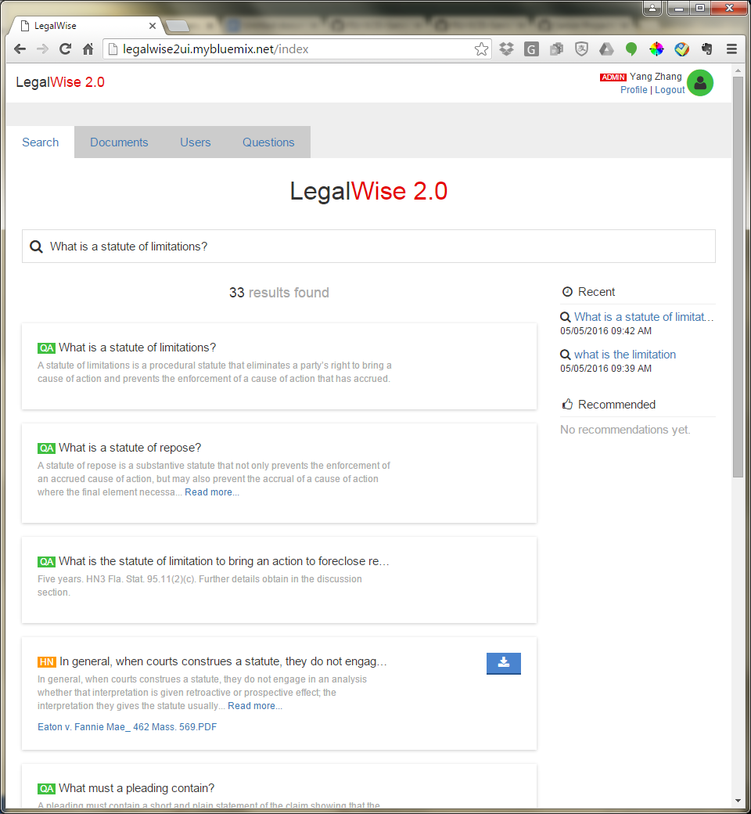

1. With entering your question/keywords, the search results will be displayed as above. The first one is the most recommended answer to this question.
2. If you would like to view or download the reference legal case document, click the blue download button, you will open the PDF legal case document as below.

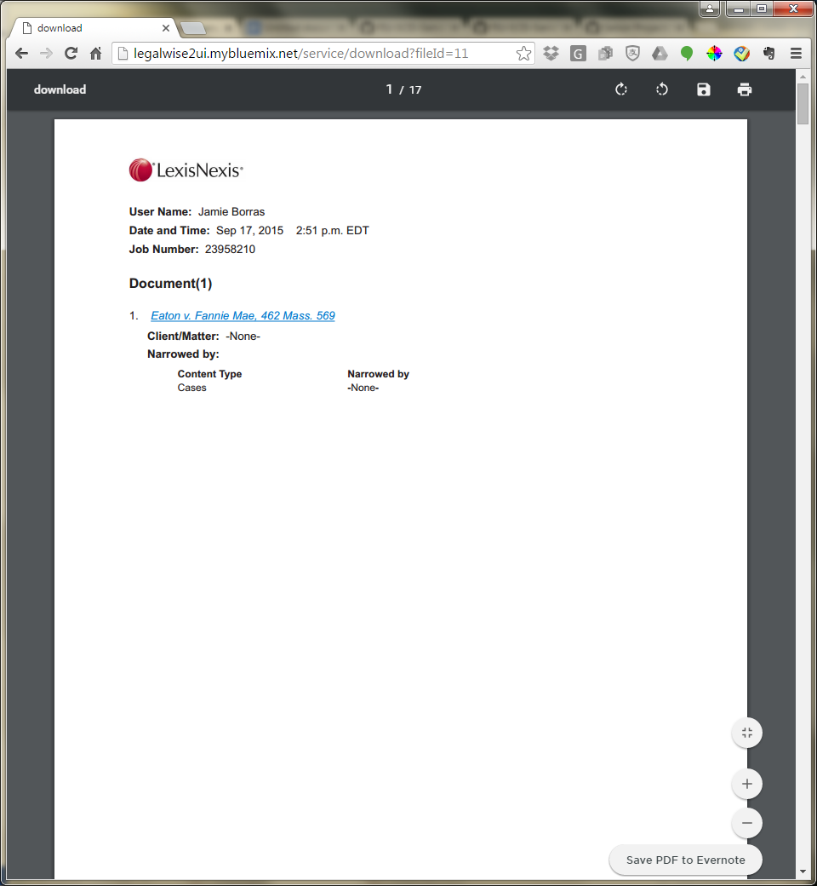

1. From here you can download this legal case by clicking the save button up right.

## View Recent Search History

1. Once you had searched for something. There will be a list of search history at the right side of the search page. 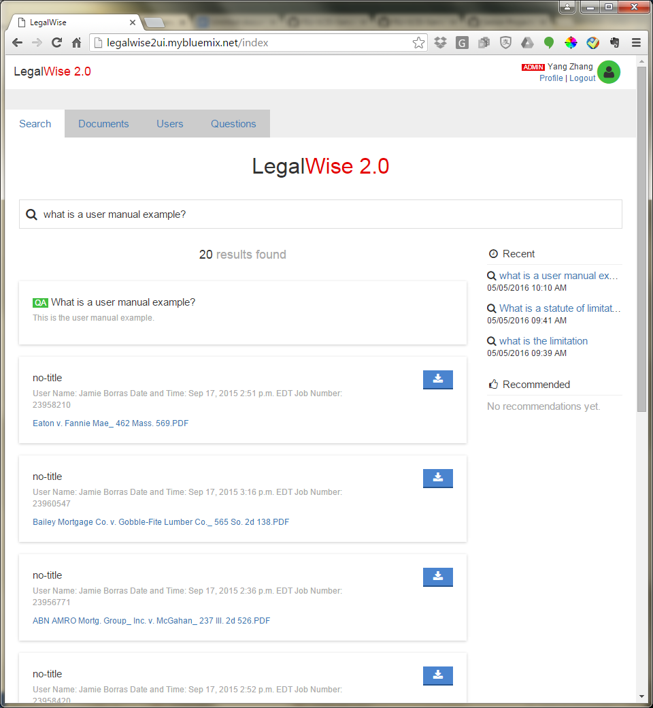
2. From there, you could click the questions and it will search again without re-type your question.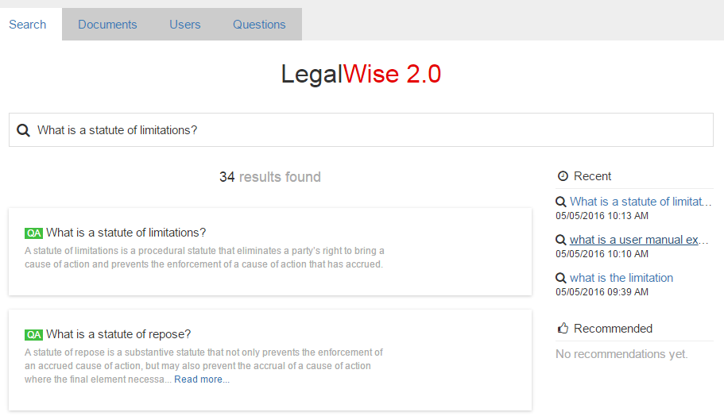

## Logout

1. At the top right corner of the page, click Logout.



1. Then you will see the login page. 

# For Administrators

Besides what a registered user could do, the administrators are also able to do the following.

## Upload PDF Legal Case Documents

1. Click the “Documents” tab.
2. Drag your documents to the page as shown.

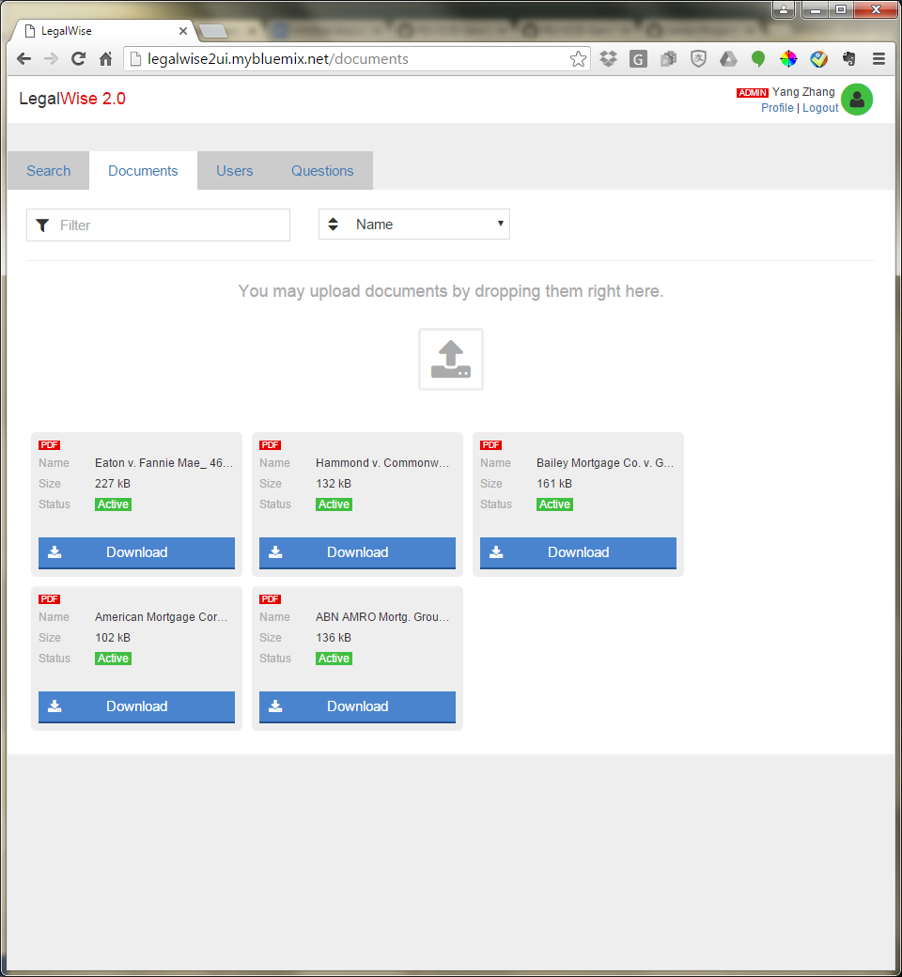

1. Leave the document on the page, and it’s done.
2. The document uploaded will be automatically indexed also.

## User Controls

1. Click the “Users” tab.

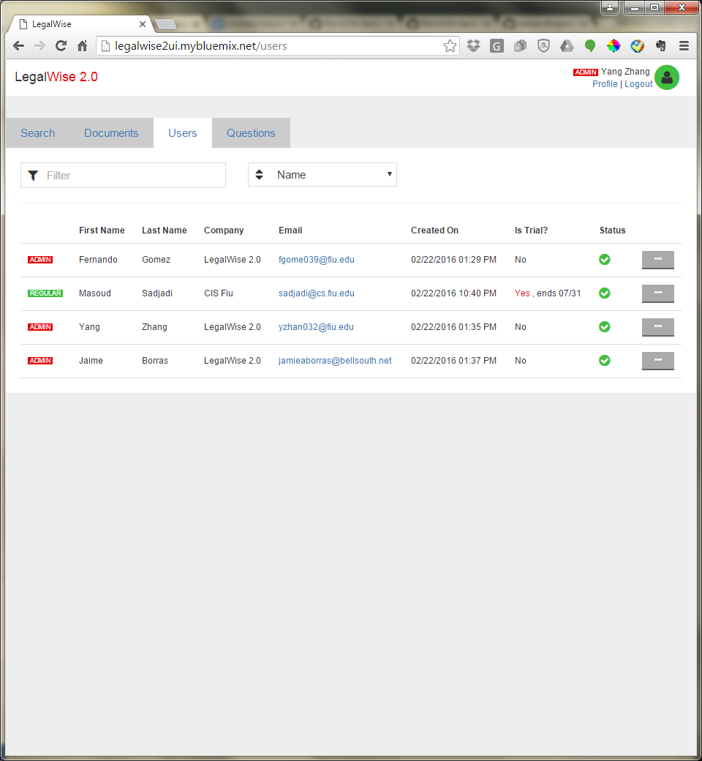

1. Click the grey button to the right of each user.

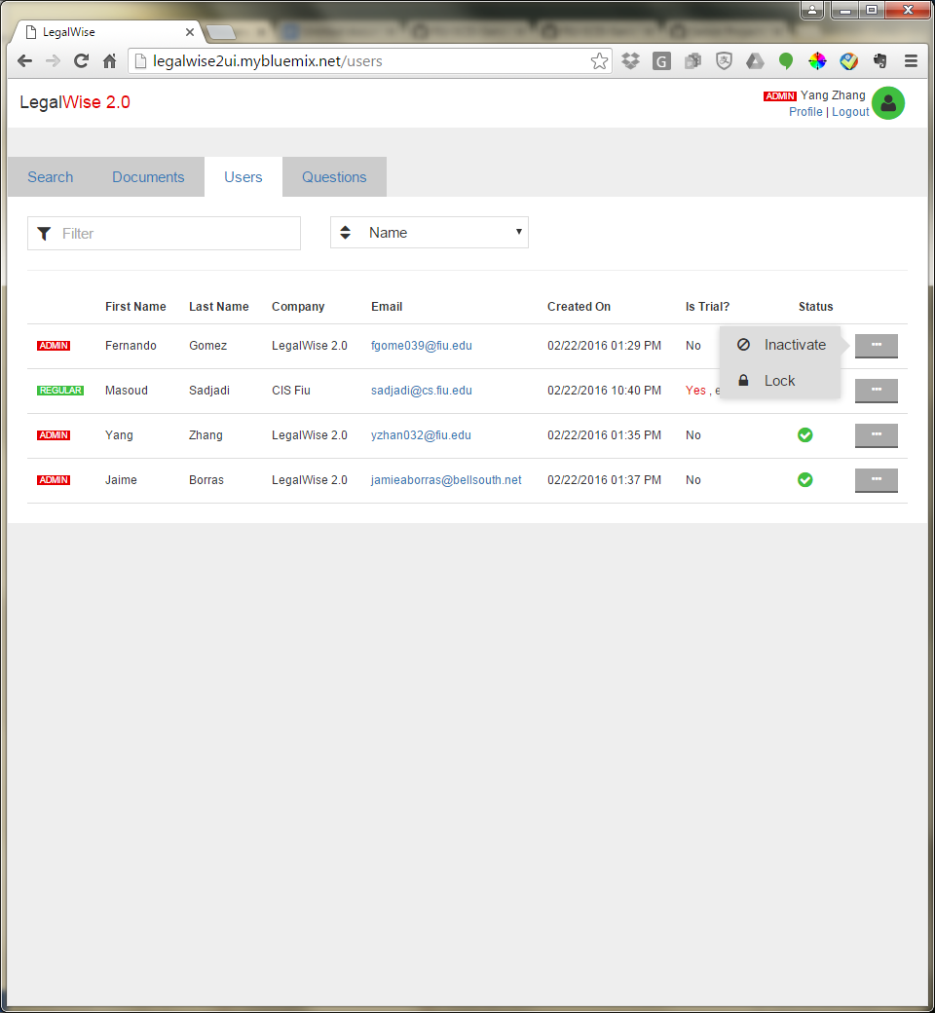

1. Choose the option to activate/inactivate or lock/unlock the chosen user.

# Add Question and Answer Pairs to System

1. Click “Questions” tab and you will see this page.

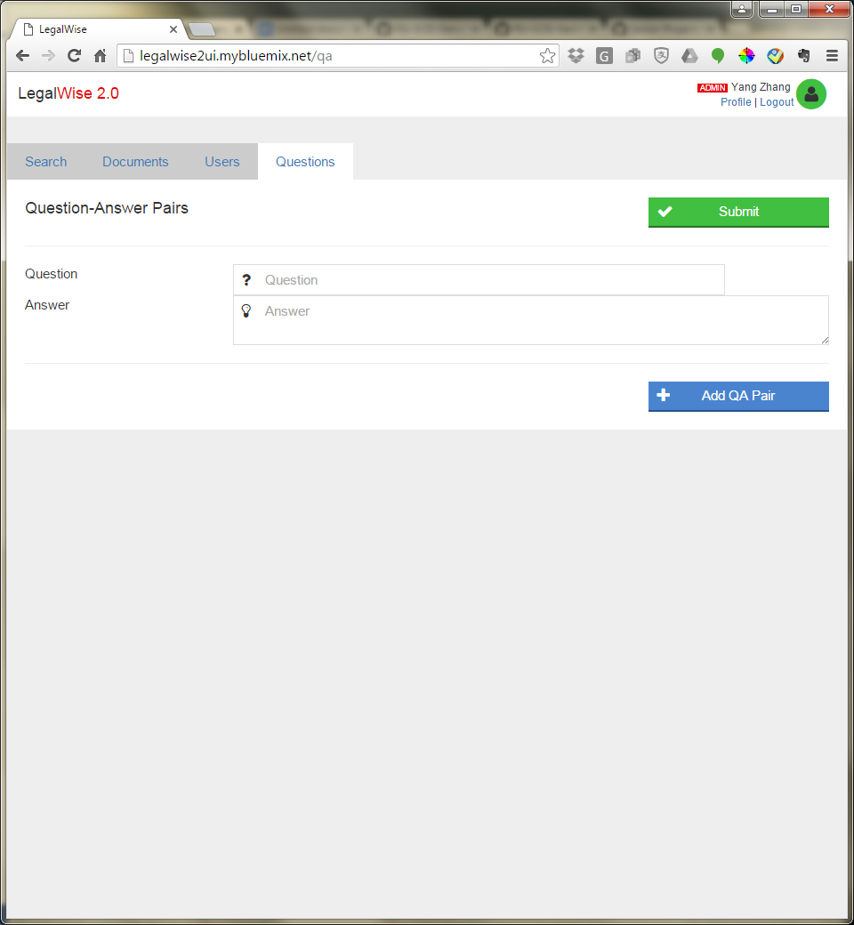

1. Enter the question and answer pairs into the input boxes accordingly. If you would like to add multiple pairs, just click the blue “Add QA Pair” button. And you will see one more input box pairs. Repeat this step if you need to add more pairs.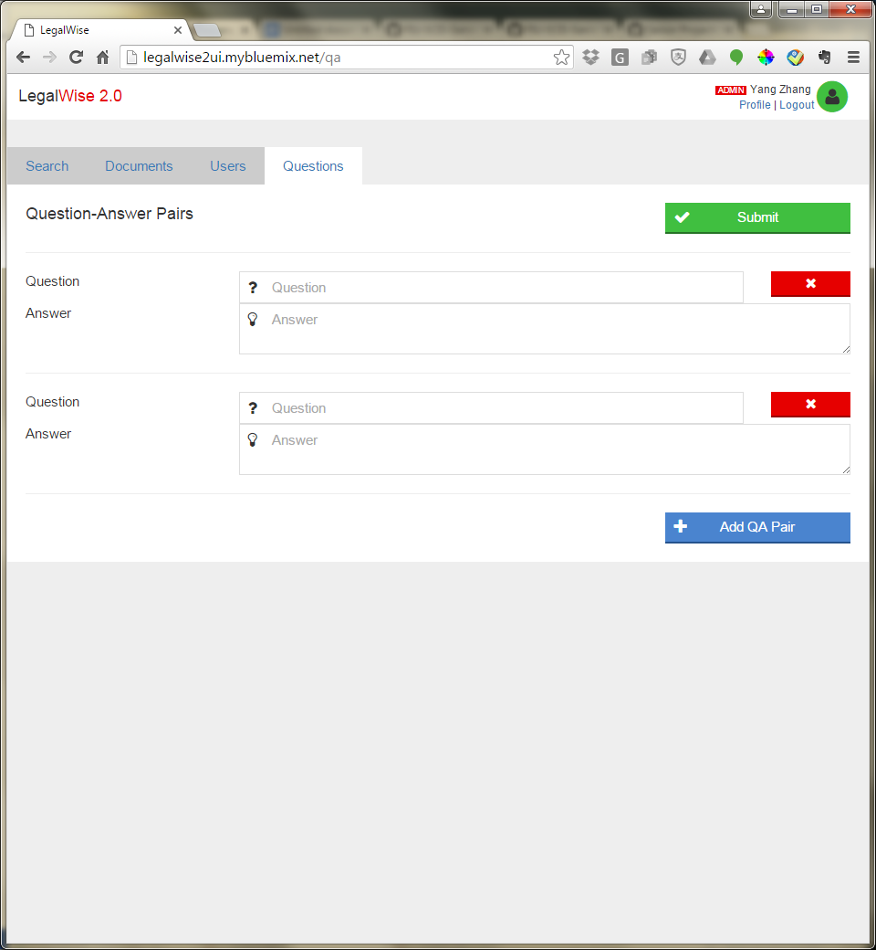
2. If you decide not to add a question, just click the red button with an “x” to give up adding it. 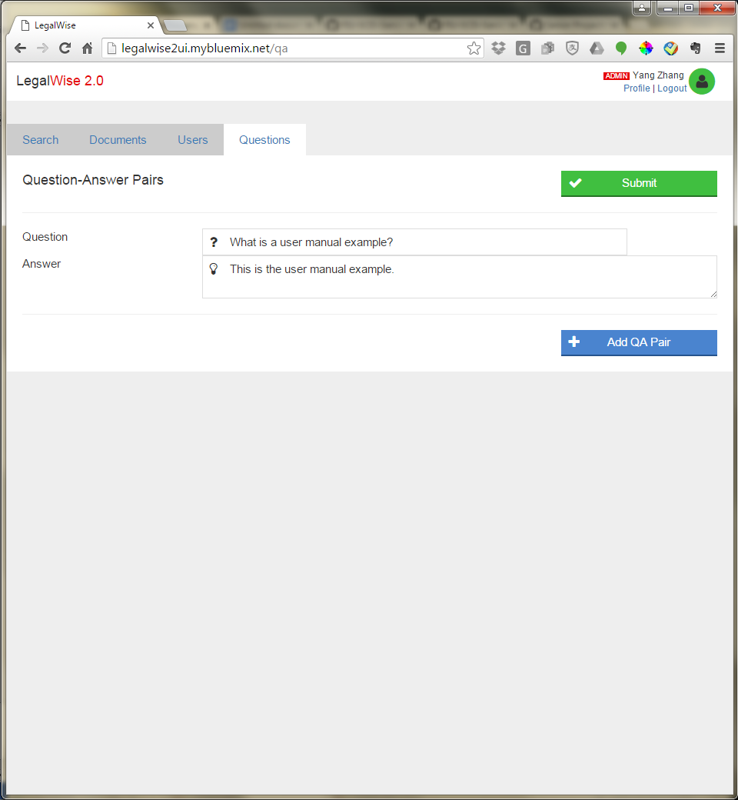
3. Then click the green “Submit” button to submit to the system. The pairs you just added will be automatically indexed while adding to the system. And the success message will be shown as below. 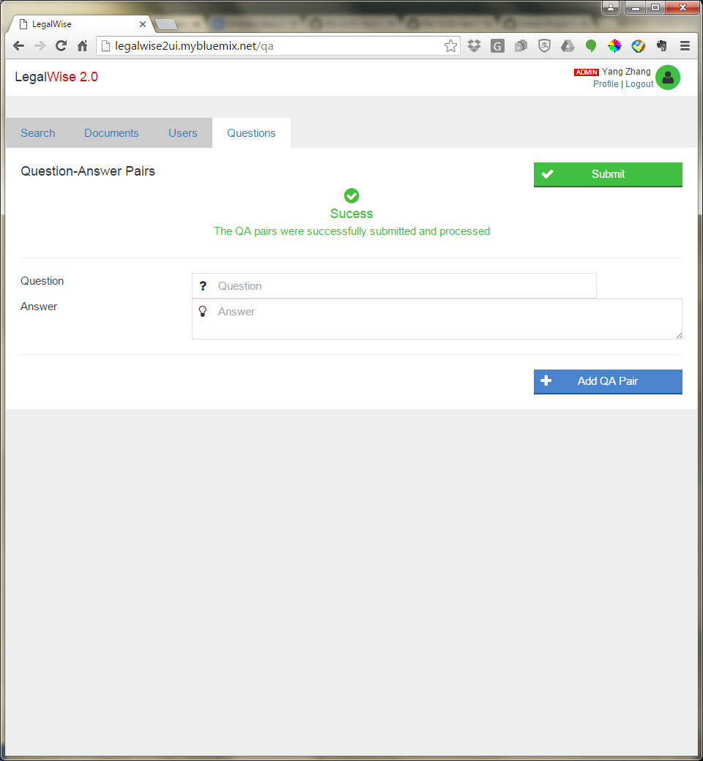
4. To test if what you had just added to the system has been indexed, just go to the “Search” tab and enter your question. 
5. The first answer is the most recommended answer and is what just added.